* 1. Homework #2: Control flow and Array (Deadline 20th April by 5pm)
     1. \*\*\*\*\*\*\*

\*\*\*\*\*

\*\*\*  
 \*

* + 1. \*

\*\*\*

\*\*\*\*\*

\*\*\*\*\*\*\*

* + 1. ABCDE

ABCD

ABC

AB

A

* + 1. A

AB

ABC

ABCD

ABCDE

* + 1. Assignment on Hotel Management (Deadline 25th April by 5pm)

Figure 1: Welcome Page

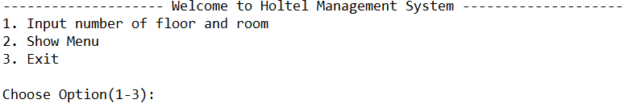

Figure 2: Set Floor and Room

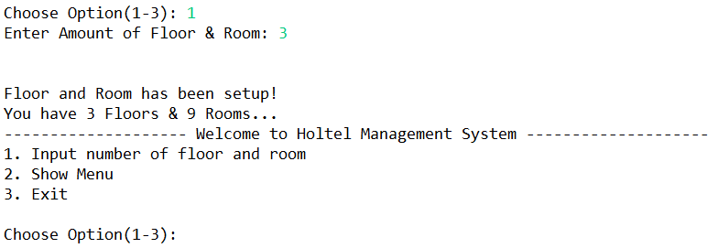

Figure 3: Show Menu

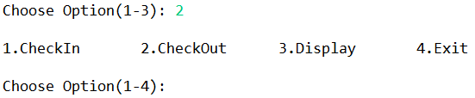

Figure 4: Check In

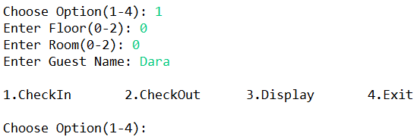

Figure 5: If the room is already check in

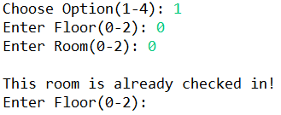

Figure 6: Check Out

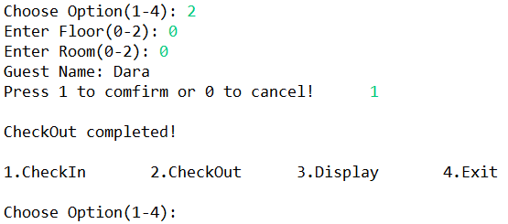

Figure 7: If the room is not yet checked in

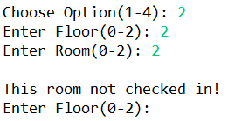

Figure 8: Display

